JUNIOR FINANCIAL DATA ANALYST INTERNSHIP
Strategic Financial Analysis & Planning
A planning document for a financial assessment of Tata Consultancy Services (TCS) and the Indian IT services peer set
Week 1 Deliverable
Prepared by: Swarnadeep Dey
Programme: Yuvaintern, Junior Financial Data Analyst
Date: October 2026
Data cut-off: Q1 FY27 results (quarter ended 30 June 2026), as published up to September 2026
How to read this document
The task asks for a simulated engagement. I act as a junior analyst supporting a hypothetical client, an equity research desk that wants a structured view of TCS. TCS and its peers are real companies, so every figure in the research sections comes from public sources listed in Section 10. The client, its questions, and its deadlines are fictional.

1. Executive Summary
The engagement. The client wants to know whether TCS's position as the most profitable large Indian IT services company is durable, and what that implies for its earnings over the next two to four quarters. This document is the plan for answering that question. It does not answer it. It sets out what we know from public data, what we still need to test, how we will test it, and where the analysis could go wrong.
Five insights from initial research
- TCS leads on profitability. Its Q1 FY27 operating margin was 24.0%, against 21.1% for Infosys, 16.9% for HCLTech and 16.0% for Wipro's IT services business.
- Real growth is much weaker than headline growth. Full-year FY26 revenue grew 4.6% in rupees but fell 2.4% in constant currency. In Q1 FY27 rupee revenue grew 13.9% while constant-currency growth was 3.2%. A large part of the reported growth is currency, not demand.
- Margins are being traded for capacity. Operating margin slipped from 25.3% in Q4 FY26 to 24.0% in Q1 FY27 as wage hikes took effect, while TCS added 9,279 employees in the quarter, its first meaningful net hiring in over a year.
- Forward visibility is strong. FY26 total contract value (TCV) was $40.7 billion, about 1.36 times FY26 dollar revenue of $30.0 billion. Q1 FY27 added $9.5 billion, and annualised AI revenue reached $2.6 billion.
- Data comparability is the hidden risk. Public sources disagree on basic figures such as FY26 net profit, and peers report on different bases. The plan therefore builds in explicit data validation steps.

What the plan commits to. Five hypotheses (Section 4), a six-phase method with explicit validation rules (Section 5), a scored risk register with nine risks (Section 6), and a five-week schedule with a deliverable at each stage (Section 7). The highest-scoring risks are currency distortion of growth figures, inconsistent data across sources, and AI-driven deflation of legacy services revenue.
Recommendation. Proceed to data collection with TCS, Infosys, Wipro and HCLTech on a common footing: 12 or more quarters, constant-currency and rupee views side by side, and every figure traced to a primary filing before it enters a model.

2. Engagement Scope and Strategic Objectives

2.1 The simulated client and the core question
The simulated client is a small equity research desk covering Indian large-cap technology stocks. It has asked for a repeatable, evidence-based assessment of TCS rather than a one-off opinion. The core question is:
Core question
Is TCS's margin and growth leadership among large Indian IT services firms durable over the next 2 to 4 quarters, given currency movements, AI-driven change in service demand, and shifts in hiring and wage costs?

2.2 Objectives
Each objective is written so that a reviewer can tell whether it was met.
# | Objective | Measure of success | Delivered in
O1 | Assemble a clean, documented dataset of at least 12 quarters for TCS and three peers | Every figure traced to a primary filing; reconciliation log with zero unresolved differences | Week 2
O2 | Separate currency effects from underlying growth | Rupee and constant-currency growth shown side by side for every period | Weeks 2 and 3
O3 | Benchmark TCS against peers on profitability, growth, productivity and order book | At least six benchmark charts, each with a stated insight | Week 3
O4 | Produce a transparent short-horizon forecast of revenue and operating margin | Back-tested against held-out quarters, with error reported | Week 4
O5 | Evaluate the process and record lessons | Candid review of each phase, with specific improvements | Week 5

2.3 Scope boundaries
- In scope: TCS, Infosys, Wipro and HCLTech; quarterly and annual data from FY23 to Q1 FY27; revenue, margins, headcount, attrition, order book, currency.
- Out of scope: share price valuation and target prices, private-company comparisons, and any non-public information.
- Why these peers: they are the four largest listed Indian IT services companies by revenue, they report on the same April to March fiscal year, and all disclose constant-currency growth, which the currency hypothesis depends on.

3. Industry and Market Research

3.1 Industry backdrop
Nasscom's Annual Strategic Review 2026 estimates Indian technology industry revenue at $315 billion for FY26, up 6.1% from a revised $297 billion in FY25. Exports were about $246 billion, up 5.6%. The more revealing number is employment. The industry added roughly 135,000 people, a 2.3% rise taking headcount to about six million. Revenue is growing nearly three times faster than headcount, which suggests that AI and automation are changing how much labour each rupee of revenue needs. Nasscom puts industry AI revenue at $10 to 12 billion in FY26.
Demand has been uneven. Brokerages tracked by the press expected the six largest Indian IT firms to grow revenue only about 4% year on year in the December 2025 quarter, and noted that double-digit growth was last seen in the March 2023 quarter. Guidance for FY27 stays cautious: Infosys trimmed its constant-currency growth guidance to 1.5% to 3.0% in July 2026 while keeping its operating margin guidance at 20% to 22%.

3.2 TCS at a glance
Metric | Latest value | Period
Revenue | ₹72,275 crore (+13.9% YoY, +2.2% QoQ) | Q1 FY27
Revenue in US dollars | $7,624 million (+2.7% YoY; +3.2% constant currency) | Q1 FY27
Operating margin | 24.0% (down from 25.3% in Q4 FY26) | Q1 FY27
Net profit (attributable) | About ₹13,350 crore (+4.6% YoY) | Q1 FY27
Order book (TCV) | $9.5 billion, incl. an $800 million AI-led deal | Q1 FY27
Annualised AI revenue | $2.6 billion (+13.6% YoY) | Q1 FY27
Headcount / attrition | 593,798 / 13.6% LTM (IT services) | 30 June 2026
Full-year revenue | ₹2,67,021 crore (+4.6%); $30.0 billion (−0.5% USD, −2.4% CC) | FY26
Full-year margins | Operating 25.0% (four-year high); net 19.8% | FY26
Full-year TCV | $40.7 billion, with five mega-deals | FY26
Table 1. TCS key figures from company results as reported in the financial press and investor summaries (see Section 10). Net profit differs by about ₹70 crore between sources and will be reconciled to the filing in Week 2.

3.3 Peer benchmark
Company | Q1 FY27 revenue | Growth | Operating margin | Notes
TCS | ₹72,275 cr | +13.9% INR; +3.2% CC | 24.0% | AI run-rate $2.6 bn; TCV $9.5 bn
Infosys | ₹48,211 cr ($5,082 m) | +2.4% CC | 21.1% | FY27 CC guidance 1.5% to 3.0%
HCLTech | ₹34,579 cr | +14% INR | 16.9% | AI annualised $684 m
Wipro | IT services $2.61 bn | +0.9% USD | 16.0% (IT services) | Margin at a 15-quarter low
Table 2. Peer snapshot, Q1 FY27. Bases differ: Wipro's margin is for IT services only, and growth is quoted in different currencies, which is why the plan insists on a common basis (Section 5).
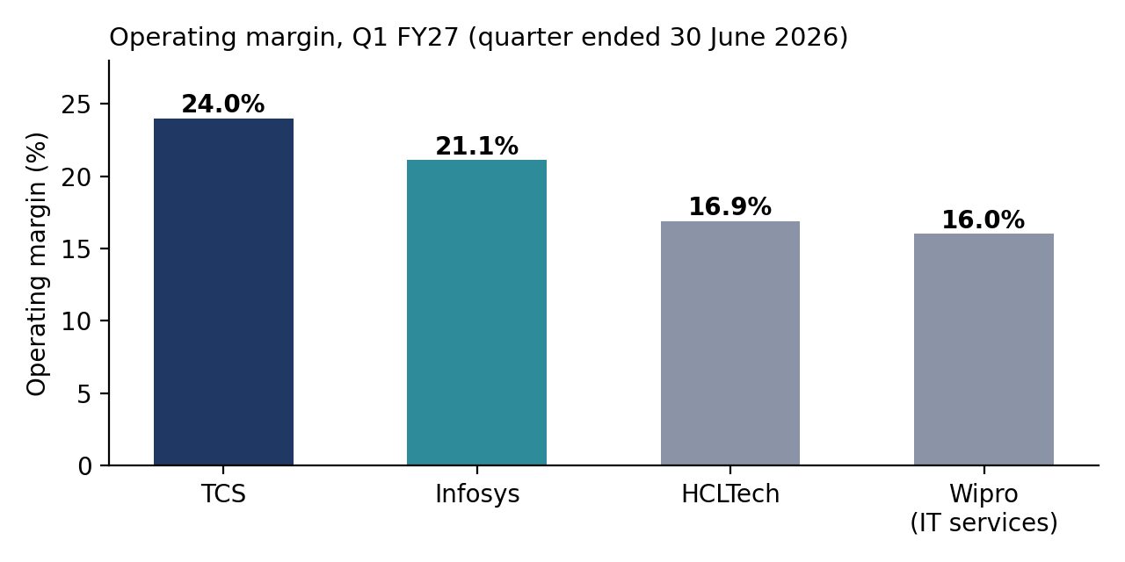
Figure 1. TCS holds a margin lead of 2.9 points over Infosys and roughly 7 to 8 points over HCLTech and Wipro. Source: company results as reported in the press.

3.4 Four themes that shape the analysis
Currency. The rupee is doing much of the work in reported growth. Figure 2 shows that FY26 revenue rose 4.6% in rupees but fell 2.4% in constant currency, and the gap widened in Q1 FY27. Any analysis that uses rupee growth alone will overstate demand. With the rupee weaker than 90 to the dollar, the effect is large.
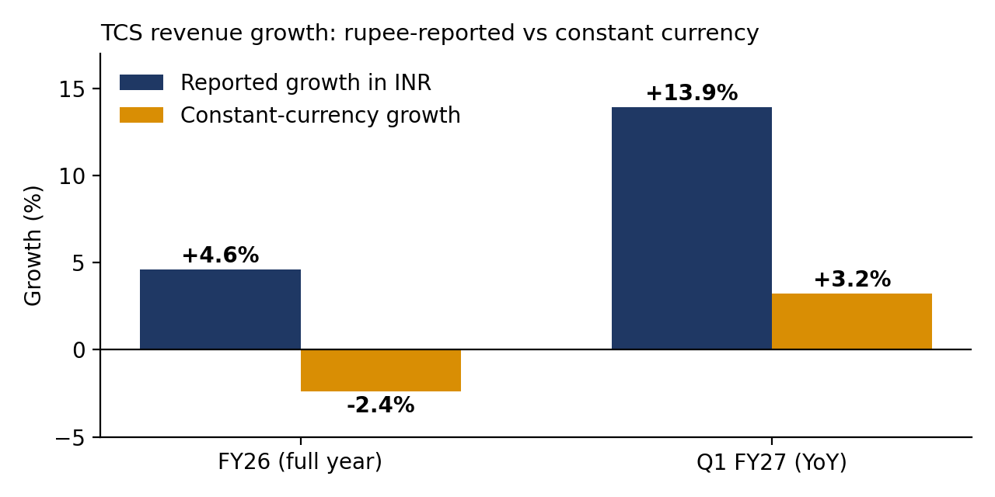
Figure 2. The gap between rupee and constant-currency growth is the currency effect. Source: TCS results as reported.
AI as both threat and revenue. TCS's AI services run-rate of $2.6 billion is about 8.5% of its annualised dollar revenue. A back-of-envelope calculation suggests AI added roughly $0.3 billion of annualised revenue over the year, against about $0.8 billion of total annualised dollar revenue growth. That would make AI close to 40% of incremental revenue, which is encouraging but needs verification. On the other side, Jefferies has warned that AI could shrink managed services, which are 22% to 45% of the revenue of leading Indian IT companies, and HSBC estimates 14% to 16% AI-driven revenue deflation. Motilal Oswal puts the loss at 9% to 12% of services revenue over three to four years. These estimates disagree widely, which is itself a finding.
Labour economics. TCS's headcount is 19,271 below a year ago even though rupee revenue is 13.9% higher. Fees paid to external consultants rose from 4.7% to 5.9% of revenue over the same year, according to one analysis of TCS disclosures, which hints at a shift from permanent to contract capacity. The Q1 wage hike cost about 170 basis points of margin.
Demand and policy. The United States is the biggest market: $4.7 billion of the $9.5 billion Q1 order book came from North America. The $100,000 annual fee on new H-1B visa applications announced in September 2025 raises the cost of onshore staffing and, according to Nasscom, threatens continuity on onshore projects.

4. Hypotheses
Each hypothesis is stated so that data can contradict it. The evidence column records what the initial research suggests, not a conclusion.
ID | Hypothesis | Initial evidence | Planned test
H1 | TCS's operating margin premium over peers is structural and survives wage-hike cycles. | 24.0% vs 16.0% to 21.1% in Q1 FY27, despite a 170 bp wage-hike hit | Margin spread to each peer over 12+ quarters; check whether it narrows after Q1 hikes
H2 | Most of TCS's reported rupee growth since FY25 comes from currency, not volume. | FY26: +4.6% INR vs −2.4% CC; Q1 FY27: +13.9% vs +3.2% | Decompose growth into constant-currency and FX components for all four firms
H3 | AI revenue is growing fast but is not yet large enough to offset legacy service deflation. | AI $2.6 bn (+13.6%); about 40% of incremental revenue by rough estimate | Compare AI increment with total increment; stress test with deflation scenarios of 5% to 15%
H4 | Revenue is decoupling from permanent headcount at TCS. | Headcount −19,271 YoY vs revenue +13.9% INR; consultant fees 4.7% to 5.9% of revenue | Revenue per employee trend; correlation of revenue and headcount changes
H5 | Order book strength (TCV) leads revenue by two to four quarters. | FY26 TCV $40.7 bn ≈ 1.36× FY26 dollar revenue | Lagged correlation between trailing TCV and subsequent dollar revenue

Falsification rule. If H2 holds, the later forecast in Week 4 must be built on constant-currency revenue with currency added as a separate assumption. If H5 fails, TCV will not be used as a leading indicator.

5. Analytical Methodology
The method has six phases. Phases 2 to 6 map directly onto Weeks 2 to 5, so this plan doubles as the structure for the later reports.
Phase | Activities | Output | Quality gate
1. Plan (Week 1) | Scope, research, hypotheses, risk framework | This document | Each objective has a measure; each hypothesis has a test
2. Collect (Week 2) | Pull quarterly and annual data for four firms from investor relations pages and exchange filings; record source, date and units for every figure | Raw dataset and source log | No figure enters the dataset without a primary source
3. Clean (Week 2) | Standardise units (₹ crore vs ₹ million vs $ million), fiscal periods and labels; handle missing values; reconcile conflicting sources; flag exceptional items | Clean dataset, data dictionary, reconciliation log | Totals reconcile to filings; zero unexplained gaps
4. Analyse and visualise (Week 3) | Compute growth (INR and CC), margins, revenue per employee, attrition, TCV-to-revenue; build benchmark charts | Charts, tables, interpretation | Every chart has a purpose statement and a stated insight
5. Forecast (Week 4) | Baseline (seasonal naive), then regression or time-series model on constant-currency revenue and margin; back-test on held-out quarters | Model documentation, error metrics | Model must beat the naive baseline to be kept
6. Evaluate (Week 5) | Review decisions, errors and surprises; note improvements | Reflective report | Each lesson is tied to a specific event

5.1 Key performance indicators
Area | Indicators
Growth | Revenue growth YoY and QoQ in INR, USD and constant currency; FX contribution
Profitability | Operating margin; net margin; margin change per wage-hike cycle
Productivity | Revenue per employee; headcount change; utilisation where disclosed; subcontractor cost as % of revenue
Quality of earnings | Cash conversion (operating cash flow to net profit); exceptional items; other income share of profit
Forward indicators | TCV; book-to-bill (TCV divided by revenue); AI run-rate and share of revenue
Workforce | Attrition (LTM); net hiring

5.2 Data handling rules
- Primary first. Company results releases and fact sheets are the source of record. News articles and analyst summaries are used only to locate the primary figure.
- Two views of growth. Rupee and constant currency are always shown together.
- Normalise before comparing. Convert to a common currency and period, and compare Wipro on an IT-services basis with the others.
- Keep an audit trail. Every figure carries its source, publication date and unit. Changes to the data are logged.
- Guard against look-ahead. In Week 4, the model may use only information that was public at the forecast date.

5.3 Tools
Python (pandas for cleaning, matplotlib for charts, statsmodels or scikit-learn for modelling), Excel for spot checks and reconciliation, and a GitHub repository for code and the data dictionary.

6. Risk Assessment Framework
Risks are scored on likelihood (1 to 5) and impact (1 to 5). The score is the product, banded as low (1 to 6), medium (7 to 11), high (12 to 16) and critical (17 or more). Nine risks were identified, in four groups: data, market, model and execution.
ID | Risk | L | I | Score | Mitigation
R1 | Data: sources disagree on basic figures. For example, FY26 net profit appears as ₹52,820 crore in one source and ₹49,454 crore in another, which may reflect treatment of one-off items | 4 | 4 | 16 | Use filings as source of record; log differences; report both adjusted and unadjusted profit
R2 | Data: mislabelled or stale figures in secondary sources. One summary page attributed Q1 FY26 numbers to Q1 FY27 | 3 | 4 | 12 | Cross-check each figure against two independent sources and the filing; check period labels
R3 | Data: peers report on different bases (IT services vs consolidated; USD vs INR) | 4 | 3 | 12 | Common-basis conversion rules written before extraction
R4 | Market: rupee movements distort growth comparisons | 4 | 4 | 16 | Always show constant-currency growth; add FX as an explicit forecast assumption
R5 | Market: AI-driven deflation of legacy services (estimates range from 9% to 16%) | 3 | 5 | 15 | Scenario analysis rather than a single estimate; track AI revenue disclosures
R6 | Market: US demand weakness and visa policy changes | 3 | 4 | 12 | Include a downside case; monitor guidance changes
R7 | Model: too few observations for reliable forecasting (about 12 to 20 quarters) | 4 | 3 | 12 | Keep models simple; report error intervals; compare with a naive baseline
R8 | Model: look-ahead bias or overfitting | 2 | 4 | 8 | Strict time-ordered splits; pre-registered test windows
R9 | Execution: scope creep and schedule slippage | 3 | 3 | 9 | Fixed scope in Section 2.3; weekly checkpoint against the timeline
Table 3. Risk register. L = likelihood, I = impact.

6.1 Risk heat map
Impact 5 |  |  | R5
Impact 4 |  | R8 | R6, R2 | R1, R4
Impact 3 |  |  | R9 | R3, R7
Impact 2
Impact 1
 | Likelihood 1 | Likelihood 2 | Likelihood 3 | Likelihood 4 | Likelihood 5
Figure 3. Heat map of the nine risks. Green is low, yellow medium, orange high. No risk reaches the critical band, but R1, R4 and R5 are the three to manage first.

7. Timeline and Resource Plan
The programme runs over five weeks, with each week producing one deliverable. Each task block in Figure 4 overlaps its neighbour slightly, because cleaning begins as soon as the first source is extracted and charting begins as soon as the first metric is computed.
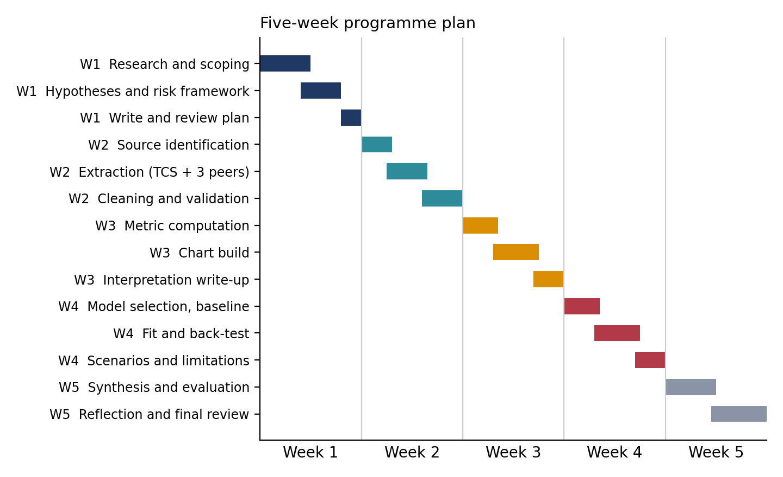
Figure 4. Five-week plan. Colours group tasks by week.
Week | Deliverable | Planned effort | Dependency
1 | Strategic plan (this document) | 30 to 35 hours | None
2 | Data collection and cleaning documentation, plus code and data dictionary | 30 to 35 hours | Data needs defined in Sections 4 and 5
3 | Visualisations and analysis report | 30 to 35 hours | Clean dataset from Week 2
4 | Forecasting and predictive modelling documentation | 30 to 35 hours | Clean dataset; trends from Week 3
5 | Reflective evaluation | 30 to 35 hours | All earlier deliverables

7.1 Resources
Resource | Use
TCS, Infosys, Wipro, HCLTech investor relations pages | Results releases, fact sheets, annual reports (sources of record)
BSE and NSE filings | Official results as filed; check on exceptional items
Reserve Bank of India data | USD/INR rates for conversion and FX decomposition
Nasscom Strategic Review | Industry totals, headcount and AI revenue context
Screening sites and financial press | Locating figures and cross-checking only, never as the final source
Python, Excel, GitHub | Cleaning, analysis, charting, version control

8. Potential Challenges and Contingencies
Challenge | What I observed during research | Planned response
Conflicting figures | FY26 net profit differs by about ₹3,400 crore between two public summaries; Q1 FY27 net profit differs slightly between sources | Reconcile to the filing; present adjusted and reported figures separately
Mislabelled periods | A widely indexed summary attributed Q1 FY26 figures (24.5% margin, $7,421 m) to Q1 FY27 | Check period labels against dates; require two sources per figure
Inconsistent reporting bases | Wipro's margin is for IT services; Infosys reports in USD and INR; HCLTech's growth is quoted in INR | Build conversion rules before extraction; document every adjustment
Short history for modelling | Only 12 to 20 quarterly observations are realistic for a four-company set | Use simple models; report intervals; compare with a naive baseline
Limited access to paid data | No terminal-grade database; reliance on public releases | Treat public filings as the standard and note the limitation
Structural breaks | Wage-hike seasonality (Q1), the BSNL contract revenue, and one-off items distort trends | Add seasonal terms; flag one-offs in the dataset

9. Critical Evaluation of the Planning Process and Recommendations

9.1 What the planning process did well
- It turned a broad question into five testable hypotheses, each with a stated test and a falsification rule.
- It found data quality problems before any modelling began, which is cheaper than finding them later.
- It tied each phase to a deliverable and a quality gate, so progress can be judged objectively.

9.2 Weaknesses and limits of this plan
- Secondary sources. The research in this document relies on press and investor summaries of company filings. That is acceptable for planning but not for analysis, which is why Phase 2 insists on primary filings.
- One sector, four firms. Conclusions will describe Indian large-cap IT services and may not transfer to global peers such as Accenture or Cognizant, whose clients and cost structures differ.
- Rough estimates. The AI share of incremental revenue (about 40%) combines rounded figures and a disclosed run-rate; it is a prompt for testing, not a finding.
- Hypothetical framing. With no real client, the question and objectives could not be refined through conversation.
- Fast-moving facts. Guidance, visa rules and AI estimates change quarterly, so some statements here may be dated by the time of review.

9.3 Recommendations for further analysis
- Add global peers (Accenture, Cognizant) in a later iteration to test whether the TCS margin lead is a sector or company effect.
- Add segment and geography data (BFSI, retail, North America, Europe) to see where growth and margin pressure originate.
- Build a margin bridge that splits quarterly margin change into wage hikes, utilisation, currency and subcontractor cost.
- Extend to cash flow and capital return (free cash flow, dividend payout, buybacks) to assess earnings quality.
- Track AI disclosures consistently, since definitions of AI revenue differ across companies and will affect any comparison.

10. References
All sources were accessed in 2026. Figures should be re-verified against company filings in Week 2.
- Business Standard. TCS Q1 FY27 results: net profit rises 4.6% to ₹13,349 cr, revenue up 13.9%. https://www.business-standard.com/companies/quarterly-results/tcs-q1fy27-result-net-profit-ebitda-attrition-foreign-orders-126070900797_1.html
- Quartr. Tata Consultancy Services Q1 26/27 earnings summary. https://quartr.com/events/tata-consultancy-services-limited-tcs-q1-26-27_3suYy74k
- Equity Research India. TCS Q1 FY27 results: revenue growth slows and margins compress as hiring resumes. https://www.equityresearchindia.com/post/tcs-q1-fy27-results-revenue-growth-slows-and-margins-compress-as-hiring-resumes
- IIFL (India Infoline). TCS Q4 results: beats estimates, announces final dividend of ₹31. https://www.indiainfoline.com/blog/tcs-q4-results
- Investing.com. TCS Q4 FY26 slides: margins hit 4-year high amid revenue rebound. https://www.investing.com/news/company-news/tcs-q4-fy26-slides-margins-hit-4year-high-amid-revenue-rebound-93CH-4606130
- Sahi. TCS Q4 FY26 results analysis. https://www.sahi.com/blogs/tcs-q4-fy26-results-analysis
- Univest. TCS Q4 FY26 results: PAT surges 12%. https://univest.in/blogs/tcs-q4-fy26-results-q4-2026-revenue-profit-dividend
- Upstox. Infosys Q1 results: FY27 revenue growth guidance narrowed to 1.5% to 3.0%. https://upstox.com/news/market-news/earnings/infosys-q1-results-fy-27-revenue-growth-guidance-narrowed-to-1-5-3-0-in-constant-currency/article-197461/
- Finology Ticker. Infosys Q1 FY27 results analysis. https://ticker.finology.in/discover/market-update/infosys-q1-fy27-results-analysis
- Finology Ticker. Wipro Q1 FY27 results analysis. https://ticker.finology.in/discover/market-update/wipro-q1-fy27-results-analysis
- Quartr. Wipro Q1 26/27 (Media) earnings summary. https://quartr.com/events/wipro-limited-wipro-q1-26-27-media_3e8Qzzrd
- Eastern Herald. TCS hits $2.6 billion AI revenue run rate in a divided Q1 FY27 for Indian IT. https://easternherald.com/2026/08/28/india-it-sector-q1-fy27-tcs-infosys-wipro-hcl-tech/
- Indian Startup News. India's tech industry set to hit $315 billion in FY26 as AI drives growth: NASSCOM. https://indianstartupnews.com/news/indias-tech-industry-set-to-hit-315-billion-in-fy26-as-ai-drives-growth-nasscom-11153971
- Sharpely. Indian IT stocks 2026: AI disruption, price crash, and why midcaps are the hidden opportunity (citing Jefferies, HSBC, Motilal Oswal). https://sharpely.in/blogs/indian-stocks-2026-ai-disruption-price-crash-midcaps-hidden-opportunity/
- Reuters via Yahoo Finance. New US H-1B visa fee could disrupt Indian IT operations, says industry body. https://finance.yahoo.com/news/us-h-1b-visa-fee-105333333.html
- Business Standard. TCS Q1 FY26 net profit rises 6%; misses estimate on revenue growth. https://www.business-standard.com/amp/companies/quarterly-results/tcs-q1-fy26-net-profit-up-6-misses-revenue-growth-estimates-125071000798_1.html

